Digital Image Processing

Experiment 10
Implementation of Smoothing filters (Linear and Non-linear) on images

CLO 1: Construct the experiments/projects of varying complexities
CLO 2: Use modern tools and languages.
CLO 3: Demonstrate an original solution of problem under discussion.
CLO 4: Work individually as well as in teams.

LAB OBJECTIVE:

The objective of this lab is to understand & implement

- Linear Smoothing Filtering

- Non-Linear Smoothing Filtering

- imnoise,fspecial and imfilter functions

1-Filtering
Image filtering can be grouped in two depending on the effects:
- Low pass filters (Smoothing)
Low pass filtering (aka smoothing), is employed to remove high spatial frequency noise from a digital image. The low-pass filters usually employ moving window operator which affects one pixel of the image at a time, changing its value by some function of a local region (window) of pixels. The operator moves over the image to affect all the pixels in the image.
- High pass filters (Edge Detection, Sharpening)
A high-pass filter can be used to make an image appear sharper. These filters emphasize fine details in the image - the opposite of the low-pass filter. High-pass filtering works in the same way as low-pass filtering; it just uses a different convolution kernel. When filtering an image, each pixel is affected by its neighbors, and the net effect of filtering is moving information around the image.

Smoothing filter

Filters are simple mathematical operators which, when convolved with logs or interpretation data, emphasize some aspect of the data, and de-emphasize others. For example, a common step in seismic horizon interpretation is to apply a filter that reduces the high spatial frequencies in the data, which are mostly attributable to noise, and emphasizes the lower frequencies. This is a smoothing filter.

Linear filters

On any digital image or seismic horizon, linear filters work by convolution with a moving window called a kernel. The input pixel is at the center of the kernel. The non-zero part of the kernel is called the support of the filter. Most filters have a square support, though some are rectangular or circular. Linear filters operate in the same way on every input pixel, applying the same weights to the same pixels in the support. They are consequently very fast, but not sensitive to the character of the data, smoothing everything equally. This is their biggest weakness for geophysical applications, since faults and channel margins, say, are smoothed along with noise and picking artifacts.

Examples includes: Mean Filter:

Mean filtering is a simple approach to implement method of smoothing images I.e. to reduce amount of intensity variation between one pixel and next .it is often used to reduce noise in images.

How it Works:

It works by simply replacing each pixel value in image with mean (average) value of its neighbors, including itself. This has the effect of eliminating pixel values which are more different form their surroundings.it represent a kernel which represent shape and size of neighborhood to be sampled when calculating the mean. Often a 3x3 square kernel is used. More large kernel (5x5) can be used for more sever smoothing.

1/9 1/9 1/9
1/9 1/9 1/9
1/9 1/9 1/9
5 6 9
A = 2 5 3
8 1 2
 | Now Pad the matrix with Zeros on all sides
 | 0 0 0  0 5 6  A= 0 2 5  0 8 1  0 0 0 | 0  9  3  2  0

- Consider a window (kernel) of size 3x3.the window can be of any size. Starting from matrix A (1, 1), place the window.

. 11  Window = . 11  . 11 | . 11 . 11  . 11 . 11  . 11 . 11

- The value to be changed is middle element .[value of A(2,2)]

- Take average of neighborhood of A(2,2) including itself

- Value to be replaced at A(2,2) in output matrix is: (0+0+0+0+.5 5+.66+0+.22+.55)=1.98
- The mean in this window is 1.98. The output matrix is placed with a value of 1.98 at (2, 2) pixel position.

- The procedure is repeated for all values in input matrix by sliding the window to next position i.e. A (1, 2) and so on.
filter2()
The filter2() is defined as:
Y = filter2(h,X)
Y = filter2(h,X) filters the data in X with the two-dimensional filter in the matrix h. It computes the result, Y, using two-dimensional correlation, and returns the central part of the correlation that is the same size as X. Now we want to apply the kernel defined in the previous section using filter2():
Example 1:
img = imread('cameraman.tif');
imgd = im2double(img); % imgd in [0,1]
f = ones(3,3)/9;
img1 = filter2(f, imgd);
subplot(121);imshow(img);
subplot(122);imshow(img1);
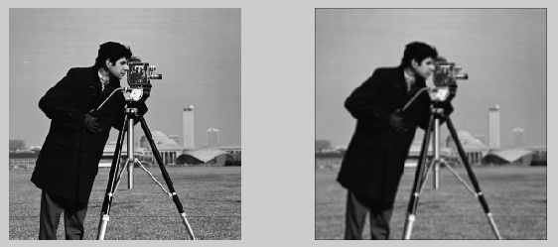
We can see the filtered image (right) has been blurred a little bit compared to the original input (left).
As mentioned earlier, the low pass filter can be used for denoising. Let's test it. First, to make the input a little bit dirty, we spray some pepper and salt on the image, and then apply the mean filter:
Example 2:
img = imread('cameraman.tif');
imgd = im2double(img); % imgd in [0,1]
imgd = imnoise(imgd,'salt & pepper',0.02);
f = ones(3,3)/9;
img1 = filter2(f, imgd);
subplot(121);imshow(imgd);
subplot(122);imshow(img1);
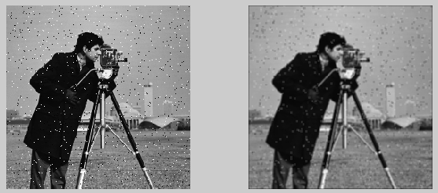
It has some effect on the salt and pepper noise but not much. It just made them blurred.

Non-linear filters

Edges are important in human perception, and it is usually desirable to preserve their sharpness. Many non-linear filters are edge-preserving, hence their importance in image processing. Non-linear filters preserve edges because they are adaptive. Not every pixel in the support contributes to the output. The pixels that do contribute are selected by some statistical criterion, usually something to do with how similar the pixels are either to each other or to the input pixel. The advantage of this is that noisy pixels contribute less to the output pixel, and edges are preserved or even enhanced.
Examples includes: Median Filter:

It is a non-linear operation used for 2-D grayscale images. It examines NxN Pixels centered on each cell of a matrix , find the median value of NxN cells and then replace the central cell value with median value .this filter is useful for removing spot noise(white spots, black spots)from an image because noisy pixels typically have values that depart significantly from median cell value .

How it Works:
• | 5 6 9  Consider a Matrix A = 2 5 3  8 1 2
• | Now Pad the matrix with Zeros on all sides
 | 0 0 0  0 5 6  0 2 5  0 8 1  0 0 0 | 0  9  3  2  0
Consider a window (kernel) of size 3x3.the window can be of any size. Starting from matrix A (1, 1), place the window.
0 0 0
Window = 0 5 6
0 2 5

- The value to be changed is middle element .[value of A(2,2)]

- Sort the window matrix: = 0 𝟎 2
5 5 6

- The median in this window is 0. After sorting the output matrix is placed with a value of 0 at (2, 2) pixel position. The value of output pixel is found using the median of the neighborhood pixels.
- The procedure is repeated for all values in input matrix by sliding the window to next position i.e. A (1, 2) and so on.

• | The output matrix is : | 3  5  2 | 0  2  0

Example 3: Applying median filter without using built-in command
img = imread('cameraman.tif');
imgd = im2double(img); % imgd in [0 , 1]
imgd=imnoise(imgd, 'salt & pepper' , 0.05);

[x , y]=size(imgd); %get size of imgd
g=zeros(x+2,y+2); %create padded imgd (called g)
B=zeros(size(imgd)); %first fill with zeros

%store imgd within g
for i=1:x
for j=1:y
g(i+1,j+1)=imgd(i,j);
end
end
%let the window be an array
%store the 3 x 3 neighbour values in the array
%store and find the middle element
for i=1:size(g,1)- 2
for j=1:size(g,2) - 2
window = zeros(3,3);
inc=1;
for x =1:3
for y = 1:3
window(inc)= g(i+x-1,j+y-1);
inc=inc+1;
end
end
med=sort(window);
disp(med)
%place the median in output matrix
B(i,j)= med(5);%median is at 5th location in 3x3 matrix.
end
end
subplot(1,3,1) ,imshow(img);title('Original Image');
subplot(1,3,2) ,imshow(imgd);title('Noisy Image');
subplot(1,3,3) ,imshow(B); title('smooth with median filter');
Example 3: Built in command for Median filter - medfilt2()
I = imread('cameraman.tif');
J = imnoise(I,'salt & pepper',0.02);
K = medfilt2(J);
subplot(121);imshow(J);
subplot(122);imshow(K);
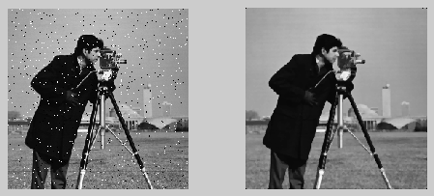
Much better. Unlike the previous filter which is just using mean value, this time we used median. Median filtering is a nonlinear operation often used in image processing to reduce "salt and pepper" noise.The medfilt2() is 2-D filter, so it only works for grayscale image.
fspecial()
Matlab provides a method to create a predefined 2-D filter.
h = fspecial(type)
h = fspecial(type, parameters)
h = fspecial(type) creates a two-dimensional filter h of the specified type. It returns h as a correlation kernel, which is the appropriate form to use with imfilter(). The type is a string having one of these values:
Value | Description
Average | Averaging filter
Disk | Circular averaging filter (pillbox)
Gaussian | Gaussian lowpass filter
Laplacian | Laplacian of Gaussian filter
Motion | Approximates the linear motion of a camera
Prewitt | Prewitt horizontal edge-emphasizing filter
Sobel | Sobel horizontal edge-emphasizing filter

Gaussian Filter:
In mean filtering the weight of neighboring pixels is same so central pixel value is just an average of neighboring pixels so it loses its detail. Gaussian filter is used to blur the images .it is used to reduce the noise and image details.in Gaussian blur Gaussian distribution is used in which central pixel value is calculated by taking weighted average of neighborhood pixels. The close the points in distance with central pixel, the larger is the weight. The 2 dimensional Gaussian function is:

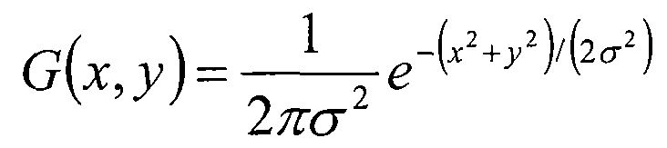

With this function we can calculate the weight of each point.

Weight Matrix:

- Assume the coordinates of center point is (0, 0).the coordinates of 8 points which are nearest to it are:

 | (−1,1) | (0,1) | (1,1)
 | (−1,0)  (−1, −1) | (𝟎, 𝟎)  (0, −1) | (1,0) (1, −1)
- To calculate the weight matrix we need to set the value of σ=1.5 then weight
 | matrix of blurred radius is
 | 0.0453542 0.0566406 | 0.0453542
 | 0.0566406 𝟎. 𝟎𝟕𝟎𝟕𝟑𝟓𝟓  0.0453542 0.0566406 | 0.0566406  0.0453542

- The sum of weights of these 9 points is 0.4787147.if only calculate the weighted average of theses 9 points , then the sum should be 1 hence the above 9 values should divide 0.4787147.

0.0947416 | 0.118318 | 0.0947416
0.118318  0.0947416 | 𝟎. 𝟏𝟒𝟕𝟕𝟔𝟏  0.118318 | 0.118318  0.09477416

Calculate the Gaussian Blur:

- With weight matrix we can calculate the value of Gaussian blur.
• | 14  Consider a Matrix A =24  34 | 15  25  35 | 16  26  36

- Each point multiplies its own weight value.
14 ∗ 0.0947416 15 ∗ 0.118318 16 ∗ 0.0947416
24 ∗ 0.118318 𝟐𝟓 ∗ 𝟎. 𝟏𝟒𝟕𝟕𝟔𝟏 26 ∗ 0.118318
34 ∗ 0.0947416 35 ∗ 0.118318 36 ∗ 0.09477416

• | Now we have
 | 1.32368 1.77477 | 1.51587
 | 2.83963 3.69403  3.22121 4.14113 | 3.07627  3.4107

- Add these 9 values up, we will get the Gaussian blur of center pixel. Repeat this process for all other pixels.

Lab Tasks:

LABTASK 1
Without using MATLAB built-in functions for applying and creating smoothing filters create an averaging filter and apply on a noisy image to smooth it.
Lab Task 2: Without using MATLAB built-in functions for applying and creating smoothing filters create an averaging/mean filter and median filter and apply on a noisy image to smooth it. Observe the results of both filters.

HOME TASK
Without using MATLAB built-in functions for applying and creating smoothing filters create a Gaussian filter and apply on a noisy image to produce Gaussian blur.

